Here’s a practical mapping of a ChatGPT-like production system onto Azure, AWS, and an on-prem GPU cluster—so you can decide architecture, cost, and control based on your goals.

🧠 1. Reference Architecture (What we’re mapping)
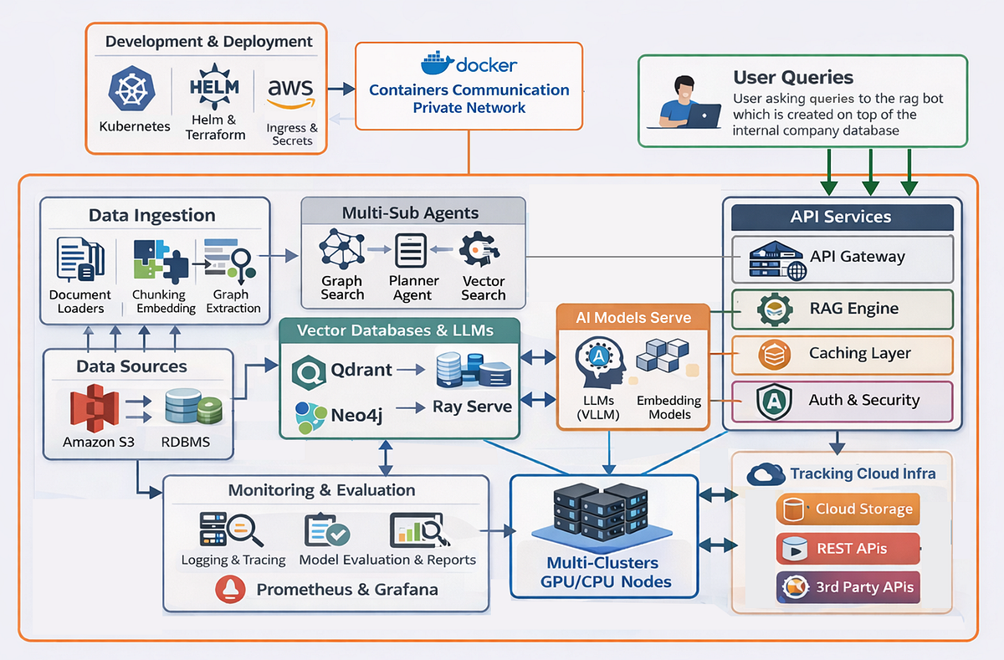
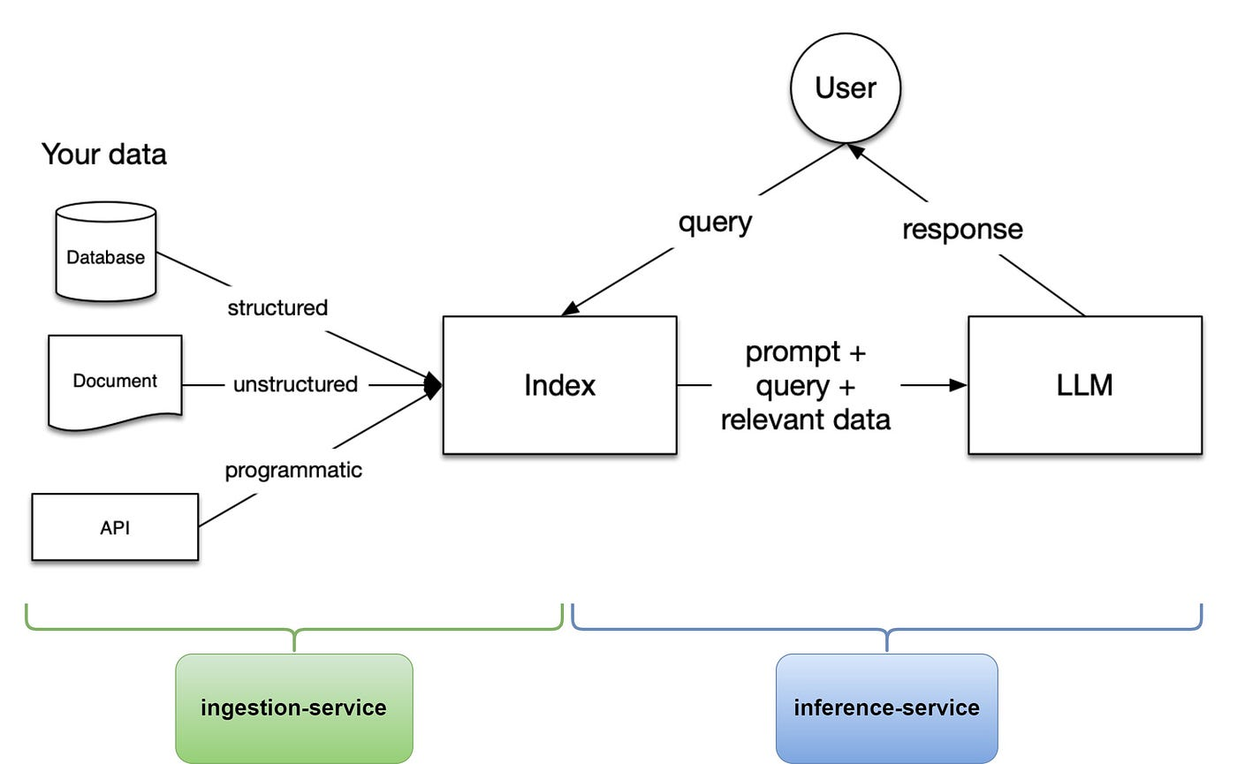
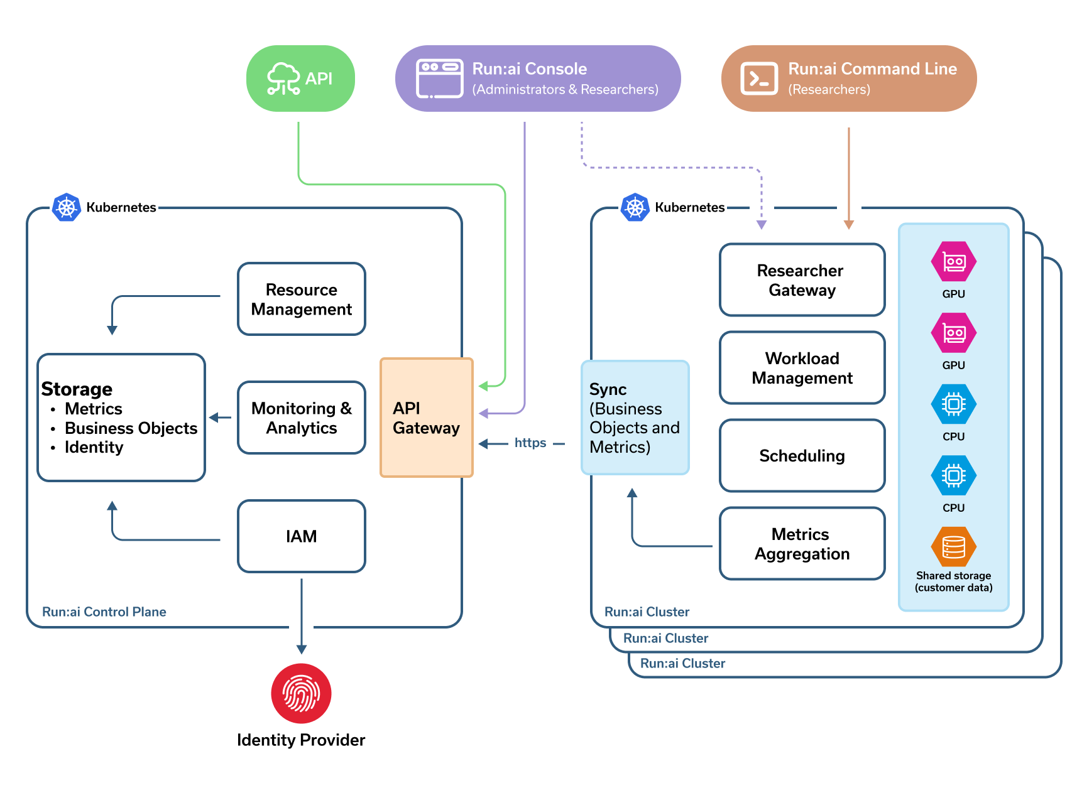
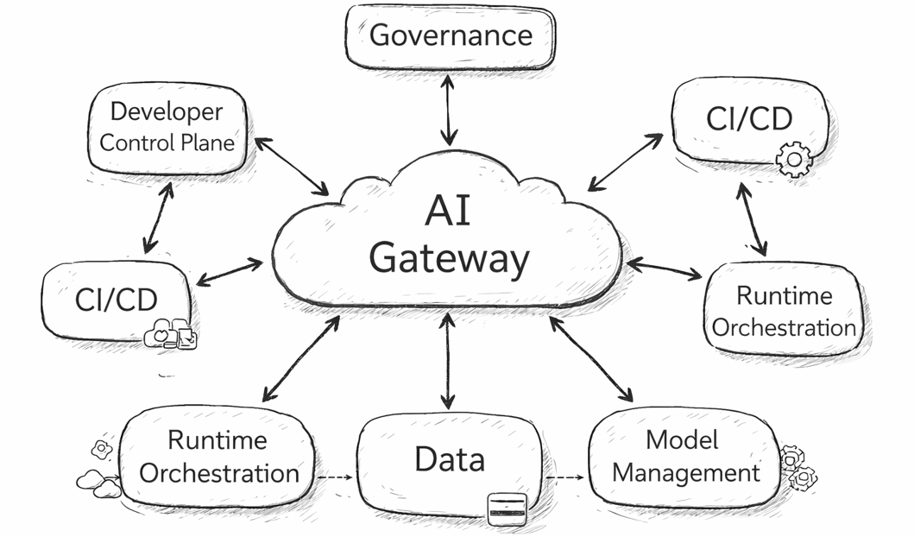
Client → API Gateway → Orchestrator → (RAG / Tools / Memory)
→ LLM Inference (GPU) → Safety → Streaming Response

☁️ 2. Mapping to Azure

🔷 Core Services
Layer | Azure Service
Frontend | Static Web Apps / App Service
API Gateway | API Management
Orchestrator | Azure Kubernetes Service (AKS)
LLM Inference | Azure ML / GPU VMs (ND, NC series)
Vector DB | Azure AI Search / Cosmos DB (vector)
Storage | Blob Storage / Data Lake
Cache | Azure Cache for Redis
Streaming | SignalR Service
Monitoring | Azure Monitor / Log Analytics

🔹 Architecture Flow (Azure)
User → Azure Front Door
→ API Management
→ AKS (Orchestrator Pods)
├─ RAG Service (Azure AI Search)
├─ Tool APIs
├─ Memory (Cosmos DB)
→ GPU Nodes (Azure ML / VM Scale Set)
→ Safety Filters
→ SignalR → Client

🔑 Strengths
- Deep integration with enterprise (AAD, security)
- Strong managed AI services
- Easier compliance (banking, gov)

☁️ 3. Mapping to AWS

🔷 Core Services
Layer | AWS Service
Frontend | S3 + CloudFront
API Gateway | Amazon API Gateway
Orchestrator | EKS (Kubernetes)
LLM Inference | EC2 GPU (P4, P5) / SageMaker
Vector DB | OpenSearch / Aurora (pgvector)
Storage | S3
Cache | ElastiCache (Redis)
Streaming | WebSockets / AppSync
Monitoring | CloudWatch

🔹 Architecture Flow (AWS)
User → CloudFront
→ API Gateway
→ EKS (Orchestrator)
├─ RAG (OpenSearch / pgvector)
├─ Tool services
├─ Memory store
→ EC2 GPU Cluster / SageMaker Endpoint
→ Moderation Layer
→ WebSocket → Client

🔑 Strengths
- Most mature ecosystem
- Flexible + cost optimization options
- Strong GPU availability

🏢 4. Mapping to On-Prem GPU Cluster

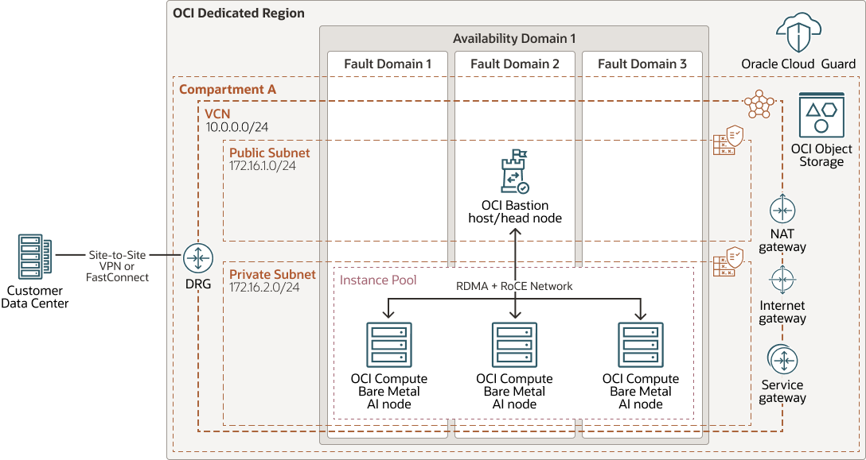
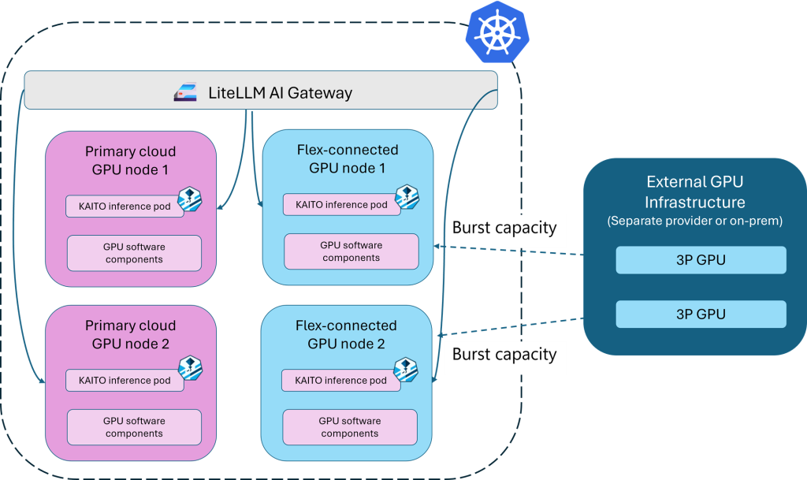
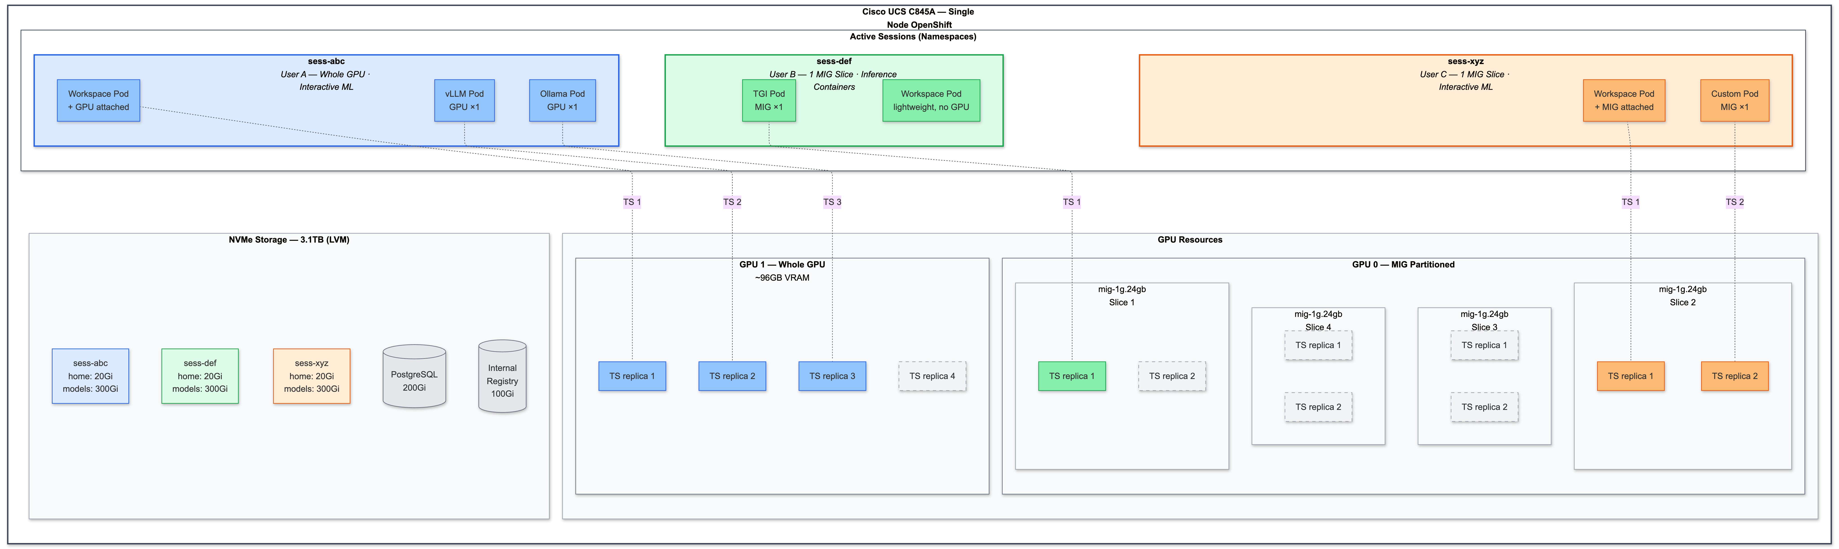

🔷 Core Stack
Layer | Tech
Frontend | Nginx / Custom
API Gateway | Kong / Nginx
Orchestrator | Kubernetes (on-prem)
LLM Inference | GPU servers (A100/H100)
Vector DB | FAISS / Milvus
Storage | Ceph / MinIO
Cache | Redis
Networking | InfiniBand / 100G Ethernet
Monitoring | Prometheus + Grafana

🔹 Architecture Flow (On-Prem)
User → Load Balancer (Nginx)
→ API Gateway (Kong)
→ Kubernetes Cluster
├─ Orchestrator Services
├─ RAG (Milvus / FAISS)
├─ Memory DB
→ GPU Nodes (Inference Pods)
→ Safety Services
→ Streaming (WebSocket)

🔑 Strengths
- Full control (data sovereignty)
- Lower long-term cost (if scaled)
- Custom hardware optimization

⚠️ Challenges
- High upfront CAPEX
- Requires strong infra team
- Scaling is slower vs cloud

⚖️ 5. Azure vs AWS vs On-Prem (Decision Matrix)
Factor | Azure | AWS | On-Prem
Setup speed | ⭐⭐⭐⭐ | ⭐⭐⭐⭐ | ⭐
Flexibility | ⭐⭐⭐ | ⭐⭐⭐⭐⭐ | ⭐⭐⭐⭐⭐
Cost (long-term) | ⭐⭐⭐ | ⭐⭐⭐⭐ | ⭐⭐⭐⭐⭐
Control | ⭐⭐⭐ | ⭐⭐⭐⭐ | ⭐⭐⭐⭐⭐
Compliance | ⭐⭐⭐⭐⭐ | ⭐⭐⭐⭐ | ⭐⭐⭐⭐⭐
GPU availability | ⭐⭐⭐⭐ | ⭐⭐⭐⭐⭐ | Depends

💰 6. Cost Rough Order (India Context)

Cloud (Azure/AWS)
- GPU (A100/H100): ₹150–₹400/hour
- Monthly (moderate system):
👉 ₹50L – ₹5 Cr

On-Prem Cluster
- 8× H100 node: ₹2–3 Cr
- Full cluster (32–128 GPUs):
👉 ₹10–50 Cr (your budget range)

🧠 7. Recommended Architecture (For YOU)
Given:
- ₹25–50 Cr budget
- Long-term AI ambition

🔥 Phase 1 (0–12 months)
👉 Use AWS or Azure
- Faster launch
- Validate product
- Build team

🔥 Phase 2 (1–3 years)
👉 Hybrid model
- Core inference → on-prem
- burst → cloud

🔥 Phase 3 (3+ years)
👉 Mostly on-prem
- Cost optimized
- Full control

🚀 Final Mental Model
Cloud = Speed + Flexibility
On-Prem = Control + Cost Efficiency
Hybrid = Best of both

🔥 One-Line Summary
Deploy ChatGPT-like systems using cloud for speed, on-prem for scale economics, and hybrid for long-term dominance

If you want next (very valuable for your goals), I can:
- Design a ₹25–50 Cr AI infra blueprint (rack-level + vendors in India)
- Give exact GPU cluster topology (NVLink, IB, rack layout)
- Map to your startup (women’s fashion AI + commerce + personalization)
Just tell me 👍
If you’re asking “which model a system like ChatGPT uses?”, here’s the clear answer:

🧠 Core Model Used in ChatGPT
👉 ChatGPT is powered by models from the OpenAI GPT family:

Main production models (recent generations):
- GPT-4
- GPT-4o
- GPT-4.1
- GPT-5 (latest class, evolving)

⚙️ What “model” means here
The model = the trained neural network:
Transformer (decoder-only)
+ trillions of tokens training
+ billions/trillions of parameters
👉 Based on
Transformer Architecture

🧩 In Production (Important Insight)
A system like ChatGPT does NOT use just one model.
It typically uses a model stack:

🔹 1. Primary LLM (Brain)
- GPT-4 / GPT-4o / GPT-5 class
- Handles reasoning, generation

🔹 2. Smaller Support Models
Used for:
- routing requests
- summarization
- fast responses
- cost optimization

🔹 3. Embedding Models
Used for RAG:
- convert text → vectors
- power semantic search

🔹 4. Safety / Moderation Models
- filter harmful input/output

🔹 5. Tool/Agent Models
- decide when to call APIs
- structured outputs

🏗️ Real Production Stack (Simplified)
User Query
↓
Router Model (cheap + fast)
↓
Main GPT Model (heavy reasoning)
↓
Optional:
- Embedding model (RAG)
- Tool model (API calls)
- Safety model

⚡ Key Insight
ChatGPT = orchestrated system of multiple models, not just one GPT

🧠 If YOU were building it
Given your architecture + startup goals:

You would choose:

Option A (Cloud)
- GPT-4o / GPT-4.1 via API

Option B (Open-source)
- LLaMA / Mistral / Mixtral class models

Option C (Hybrid)
- GPT for reasoning
- smaller local models for cost

🔥 One-Line Answer
ChatGPT uses GPT-family Transformer models (like GPT-4/4o/5), combined with multiple supporting models in a production system

If you want next, I can:
- Compare GPT vs LLaMA vs Mistral vs Claude (deep architecture + cost)
- Recommend exact model stack for your ₹25–50 Cr AI startup
- Show how to choose model based on use case (RAG, agents, coding, etc.)
Just tell me 👍

If you’re asking “which model a system like ChatGPT uses?”, here’s the clear answer:

🧠 Core Model Used in ChatGPT
👉 ChatGPT is powered by models from the OpenAI GPT family:

Main production models (recent generations):
- GPT-4
- GPT-4o
- GPT-4.1
- GPT-5 (latest class, evolving)

⚙️ What “model” means here
The model = the trained neural network:
Transformer (decoder-only)
+ trillions of tokens training
+ billions/trillions of parameters
👉 Based on
Transformer Architecture

🧩 In Production (Important Insight)
A system like ChatGPT does NOT use just one model.
It typically uses a model stack:

🔹 1. Primary LLM (Brain)
- GPT-4 / GPT-4o / GPT-5 class
- Handles reasoning, generation

🔹 2. Smaller Support Models
Used for:
- routing requests
- summarization
- fast responses
- cost optimization

🔹 3. Embedding Models
Used for RAG:
- convert text → vectors
- power semantic search

🔹 4. Safety / Moderation Models
- filter harmful input/output

🔹 5. Tool/Agent Models
- decide when to call APIs
- structured outputs

🏗️ Real Production Stack (Simplified)
User Query
↓
Router Model (cheap + fast)
↓
Main GPT Model (heavy reasoning)
↓
Optional:
- Embedding model (RAG)
- Tool model (API calls)
- Safety model

⚡ Key Insight
ChatGPT = orchestrated system of multiple models, not just one GPT

🧠 If YOU were building it
Given your architecture + startup goals:

You would choose:

Option A (Cloud)
- GPT-4o / GPT-4.1 via API

Option B (Open-source)
- LLaMA / Mistral / Mixtral class models

Option C (Hybrid)
- GPT for reasoning
- smaller local models for cost

🔥 One-Line Answer
ChatGPT uses GPT-family Transformer models (like GPT-4/4o/5), combined with multiple supporting models in a production system

If you want next, I can:
- Compare GPT vs LLaMA vs Mistral vs Claude (deep architecture + cost)
- Recommend exact model stack for your ₹25–50 Cr AI startup
- Show how to choose model based on use case (RAG, agents, coding, etc.)
Just tell me 👍

